

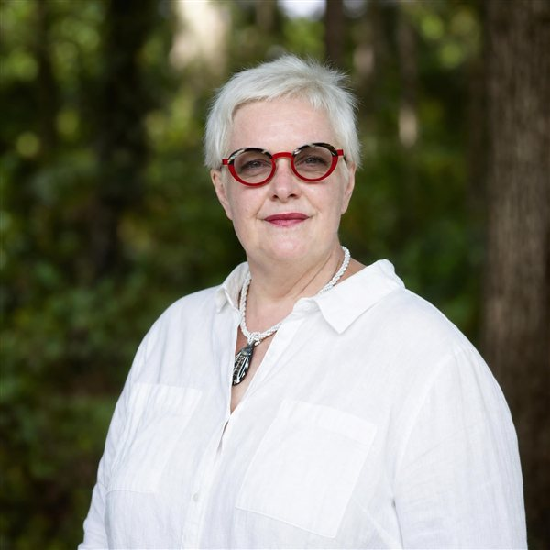  Isabelle Claus Teixeira  Executive Coach & HR Consultant  CONTACT  Location  Kyoto, Japan  Phone  +81 80 6515 1778  E-mail  isabelle@bhdasia.com  Web  bhdasia.com  Nationality  French · Japan PR  CORE COMPETENCIES  ▪ Executive & Leadership Coaching  ▪ Talent Management & OD  ▪ Leadership Development Design  ▪ HR Business Partnering  ▪ Team Effectiveness  ▪ Change & Culture Transformation  ▪ Conflict Management & Mediation  ▪ Somatic Coaching & TRE®  ▪ Mindfulness Facilitation  ▪ Cross-Cultural Leadership  LANGUAGES  ▪ French — Native  ▪ English — Fluent  ▪ Spanish — Fluent  ▪ Japanese — Intermediate  ▪ German — Basic | Professional Summary  PCC-level Leadership Coach (ICF) and senior HR leader with close to 30 years of global experience in Executive Coaching, Talent Management, and Organisational Effectiveness across Asia Pacific, Japan, Russia, the US and Europe. Certified coach since 2012 with 1,600+ paid coaching hours, a certified Teacher of Mindfulness, and a Global TRE® Certifying Trainer. Executive contributor to the Forbes Coaches Council and Brainz Magazine.  Having lived in 10 countries, Isabelle brings deep cultural agility and a global mindset to her work with C-suites, leadership teams, and emerging leaders. She founded her boutique coaching and leadership-development consultancy in Singapore in 2016, designing award-winning solutions in leadership transition, team effectiveness, organisational culture, and retention.  Work Experience  Founder, Managing Director & Executive Coach Dec 2016 – Present  BHD Asia — Singapore & Global  • Design and facilitate customised leadership-development, high-performing-team and emerging-leader programmes for global clients.  • Executive, leadership, transition and career coaching for C-suites, CEOs and board chairs.  • Conflict management and mediation; employee-engagement and burnout-prevention programmes.  • HR consulting, organisational-culture initiatives, and HR capability building.  • Clients include Mondelez, Clariant, Siemens, Schindler, Keppel, Syngenta, ByteDance (TikTok), NTT DATA, Novartis, Zimmer Biomet, Philips, Fresenius Medical Care, Alcon, Heineken Asia Pacific, DSM, VISA, Mastercard, Robert Walters, UWC SEA and Eton House.  Global Human Resources Business Partner Jan 2022 – Aug 2024  Tokyo, Japan  • Business partner to 4 Presidents (CEO-1) across software development, enterprise technology and cyber security, plus 2 site leaders in Japan, the UK and USA.  • Principal HRBP for a 950-employee, 55-nationality workforce across Japan, California and the UK; reported to the US-based CHRO.  • Designed and implemented a world-class Management Development programme, sourcing world-class faculty.  • Sourced executive coaches, designed a COO-team effectiveness workshop, and led Diversity & Inclusion and employee-wellbeing initiatives.  • Led change management through three major re-organisations in under eight months.  Head of Talent Management & OD, Japan & Asia/Russia Mar 2013 – Nov 2016  Singapore — covering 15 countries  • Created the Talent Management & Organisational Development function across Asia, Russia and Japan during a period of fast growth and change.  • Built a talent mindset and a strong pipeline of Asian talent; implemented programmes to reduce turnover and develop regional HR and leadership.  • Awards: Global Alcon HR Breakthrough Award (2014); Novartis Group Global Talent & Leadership Development Excellence Award (2014); Most Valuable Team, Alcon (2014).  Director, Talent & Leadership Development, Asia & Japan Jul 2010 – Feb 2013  Singapore — covering 6 countries  • Created the first Talent Management & OD role in Asia & Japan within a highly centralised organisation.  • Championed the region's talent agenda, influenced global HR & talent strategy, and established regional best practices.  Global HR Business Partner — Ocean Transportation Mar 2008 – Jun 2010  Geneva, Switzerland — 250 staff across 8 locations  • Built a "One Team" culture and increased employee engagement across Asia Pacific, Europe and North America.  • Transformed operations into a flexible, scalable, follow-the-sun delivery model.  • Recipient of the Business Excellence Award (2009) for employee engagement and strategic planning.  EMEA HR Manager, IT Oct 2006 – Feb 2008  Brussels, Belgium — 500+ staff across 14 countries  • Led HR through the transformation from a regional structure to a global delivery model.  • Delivered major outsourcing projects and the reorganisation of IT Applications & Infrastructure.  HR Director, Spain & Portugal Feb 2004 – Sep 2006  Madrid, Spain — 400+ employees; member of the Iberia Executive Committee  • Led a major acquisition integration, business-model optimisation, and HR restructuring.  Earlier HR roles — Quintiles & Electronic Data Systems 1996 – 2004  France, Germany & UK  • HR Manager Continental Europe (Quintiles) and HR Partner EMEA (EDS) — restructuring, integration and regional HR initiatives across Europe.  Education  Master (DESS), Labour Law & Human Resource Management (Grade A) 1995  University of Paris X, France  Diploma in Law (Social Relations) 1996  University of Kent at Canterbury, United Kingdom  Organization Design Certificate (Part 1) 2011  USC Marshall — Center for Effective Organizations, Los Angeles  Certifications & Accreditations  • Advanced Coaching Skills — Coaching with Gestalt, Academy of Executive Coaching (2026)  • Global TRE® Certifying Teacher (2020–2025); Certified TRE® Provider (2019)  • Certified Mindfulness Teacher — UK College of Mindful Meditation (2024); Trauma-Sensitive Mindfulness — David Treleaven (2025)  • PCC Coach — International Coaching Federation (2019)  • Somatic Coaching — Strozzi Institute (2019); Foundations of Embodiment (2020)  • Team Coach Certification, Level I — Leadership in Motion (2022)  • Brain-based Coaching — NeuroLeadership Institute (2018)  • Accredited Mediator — Singapore International Mediation Institute (2017)  • Leading & Coaching Across Cultures (COF) — Rosinski & Company (2021)  • Stakeholder-Centered Coaching — Marshall Goldsmith (2012); MBTI I & II; NLP Practitioner; DISC  Awards  • Global Alcon HR Breakthrough Award (2014)  • Novartis Group Global Talent & Leadership Development Excellence Award (2014)  • Business Excellence Award — Employee Engagement & Strategic Planning (2009)  Interests  Oil & acrylic painting · Intelligent yoga · Japanese tea ceremony · Zazen & mindfulness.

